PAPER TITLE TNR 14p bold

Author 1 Surname, Name , Author 2 Surname Name TNR 12p bold

Abstract: 5-15 lines, TNR 10p italic

Key words: 4-7 key words, TNR 10p italic

1. INTRODUCTION, TNR 11p bold

Body text, 11p normal, paragraph first line 12.5 mm.

2. TITLE HEADER, TNR 11p bold

2.1. Subtitle header, TNR 11p bold italic

Body text, 11p normal, paragraph first line 12.5 mm.

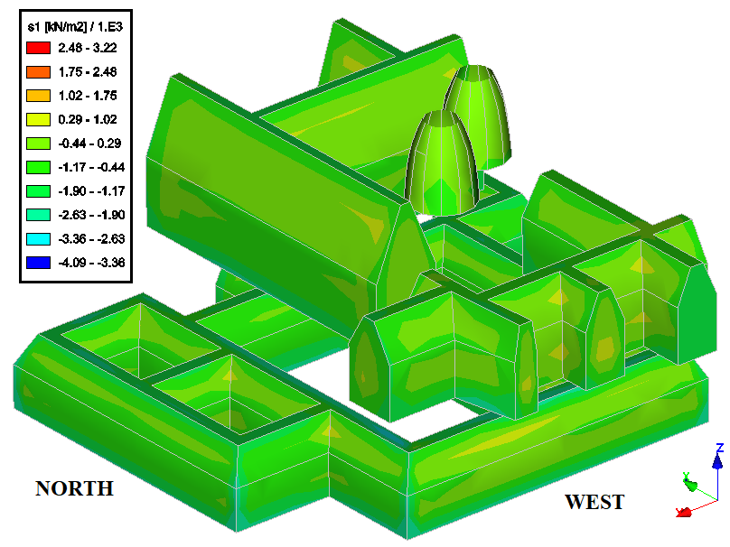
Figure 1. Figure title 10p TNR

Table 1. Table title 10p TNR
Heading 1 | Heading 2 | 10p TNR bold
Content 1 | Content 2 | 10p TNR

Formula, TNR 11p alignment right (1)

2.2. Subtitle header, TNR 11p bold italic

Body text, 11p normal, paragraph first line 12.5 mm. Body text, 11p normal, paragraph first line 12.5 mm. Body text, 11p normal, paragraph first line 12.5 mm. Body text, 11p normal, paragraph first line 12.5 mm. Body text, 11p normal, paragraph first line 12.5 mm. Body text, 11p normal, paragraph first line 12.5 mm. Body text, 11p normal, paragraph first line 12.5 mm. Body text, 11p normal, paragraph first line 12.5 mm. Body text, 11p normal, paragraph first line 12.5 mm. Body text, 11p normal, paragraph first line 12.5 mm. Body text, 11p normal, paragraph first line 12.5 mm. Body text, 11p normal, paragraph first line 12.5 mm.
Body text, 11p normal, paragraph first line 12.5 mm. Body text, 11p normal, paragraph first line 12.5 mm. Body text, 11p normal, paragraph first line 12.5 mm. Body text, 11p normal, paragraph first line 12.5 mm. Body text, 11p normal, paragraph first line 12.5 mm. Body text, 11p normal, paragraph first line 12.5 mm. Body text, 11p normal, paragraph first line 12.5 mm. Body text, 11p normal, paragraph first line 12.5 mm. Body text, 11p normal, paragraph first line 12.5 mm. Body text, 11p normal, paragraph first line 12.5 mm. Body text, 11p normal, paragraph first line 12.5 mm. Body text, 11p normal, paragraph first line 12.5 mm.
Body text, 11p normal, paragraph first line 12.5 mm. Body text, 11p normal, paragraph first line 12.5 mm. Body text, 11p normal, paragraph first line 12.5 mm. Body text, 11p normal, paragraph first line 12.5 mm. Body text, 11p normal, paragraph first line 12.5 mm. Body text, 11p normal, paragraph first line 12.5 mm. Body text, 11p normal, paragraph first line 12.5 mm. Body text, 11p normal, paragraph first line 12.5 mm. Body text, 11p normal, paragraph first line 12.5 mm. Body text, 11p normal, paragraph first line 12.5 mm. Body text, 11p normal, paragraph first line 12.5 mm. Body text, 11p normal, paragraph first line 12.5 mm.
Body text, 11p normal, paragraph first line 12.5 mm. Body text, 11p normal, paragraph first line 12.5 mm. Body text, 11p normal, paragraph first line 12.5 mm. Body text, 11p normal, paragraph first line 12.5 mm. Body text, 11p normal, paragraph first line 12.5 mm. Body text, 11p normal, paragraph first line 12.5 mm. Body text, 11p normal, paragraph first line 12.5 mm. Body text, 11p normal, paragraph first line 12.5 mm. Body text, 11p normal, paragraph first line 12.5 mm. Body text, 11p normal, paragraph first line 12.5 mm. Body text, 11p normal, paragraph first line 12.5 mm. Body text, 11p normal, paragraph first line 12.5 mm.
Body text, 11p normal, paragraph first line 12.5 mm. Body text, 11p normal, paragraph first line 12.5 mm. Body text, 11p normal, paragraph first line 12.5 mm. Body text, 11p normal, paragraph first line 12.5 mm. Body text, 11p normal, paragraph first line 12.5 mm. Body text, 11p normal, paragraph first line 12.5 mm.
3. CONCLUSIONS

Body text, 11p normal, paragraph first line 12.5 mm. Body text, 11p normal, paragraph first line 12.5 mm. Body text, 11p normal, paragraph first line 12.5 mm. Body text, 11p normal, paragraph first line 12.5 mm. Body text, 11p normal, paragraph first line 12.5 mm. Body text, 11p normal, paragraph first line 12.5 mm. Body text, 11p normal, paragraph first line 12.5 mm. Body text, 11p normal, paragraph first line 12.5 mm. Body text, 11p normal, paragraph first line 12.5 mm. Body text, 11p normal, paragraph first line 12.5 mm. Body text, 11p normal, paragraph first line 12.5 mm. Body text, 11p normal, paragraph first line 12.5 mm.

4. REFERENCES

[1]. Author, Paper title, Publisher (year) – TNR, 10p

Do not insert page numbers

Author 1 title, afiliation
Author 2 title, afiliation

